**Zomato Data Analysis Report**

This report presents an exploratory data analysis (EDA) of Zomato restaurant data, showcasing key insights and trends found  
in the dataset. It includes visualizations  
and summaries derived using Python

# **Summary & Key Insights**

1. The majority of couples prefer restaurants with an approximate cost of 300 rupees.

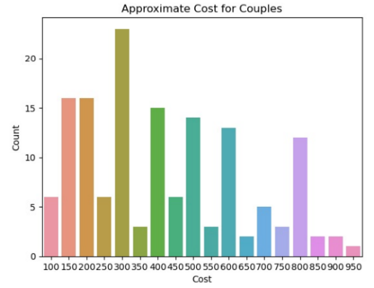

1. The majority of the restaurants fall into the dining category.

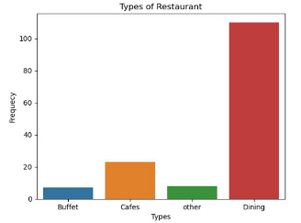

1. Dining restaurants are preferred by a larger number of individuals.

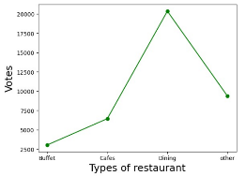

1. The majority of restaurants have ratings between 3.0 to 4.5

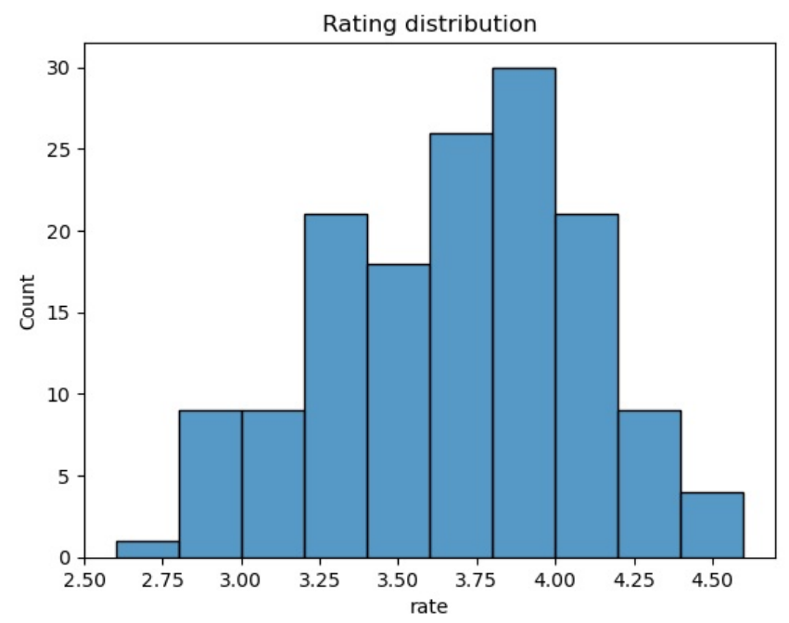

1. The majority of the restaurants do not accept online orders.

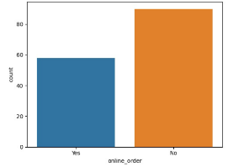

1. Dining restaurants primarily accept offline orders whereas cafes primarily receive online orders. Additionally, clients prefer to place orders in person at restaurants but prefer online ordering at cafes.

